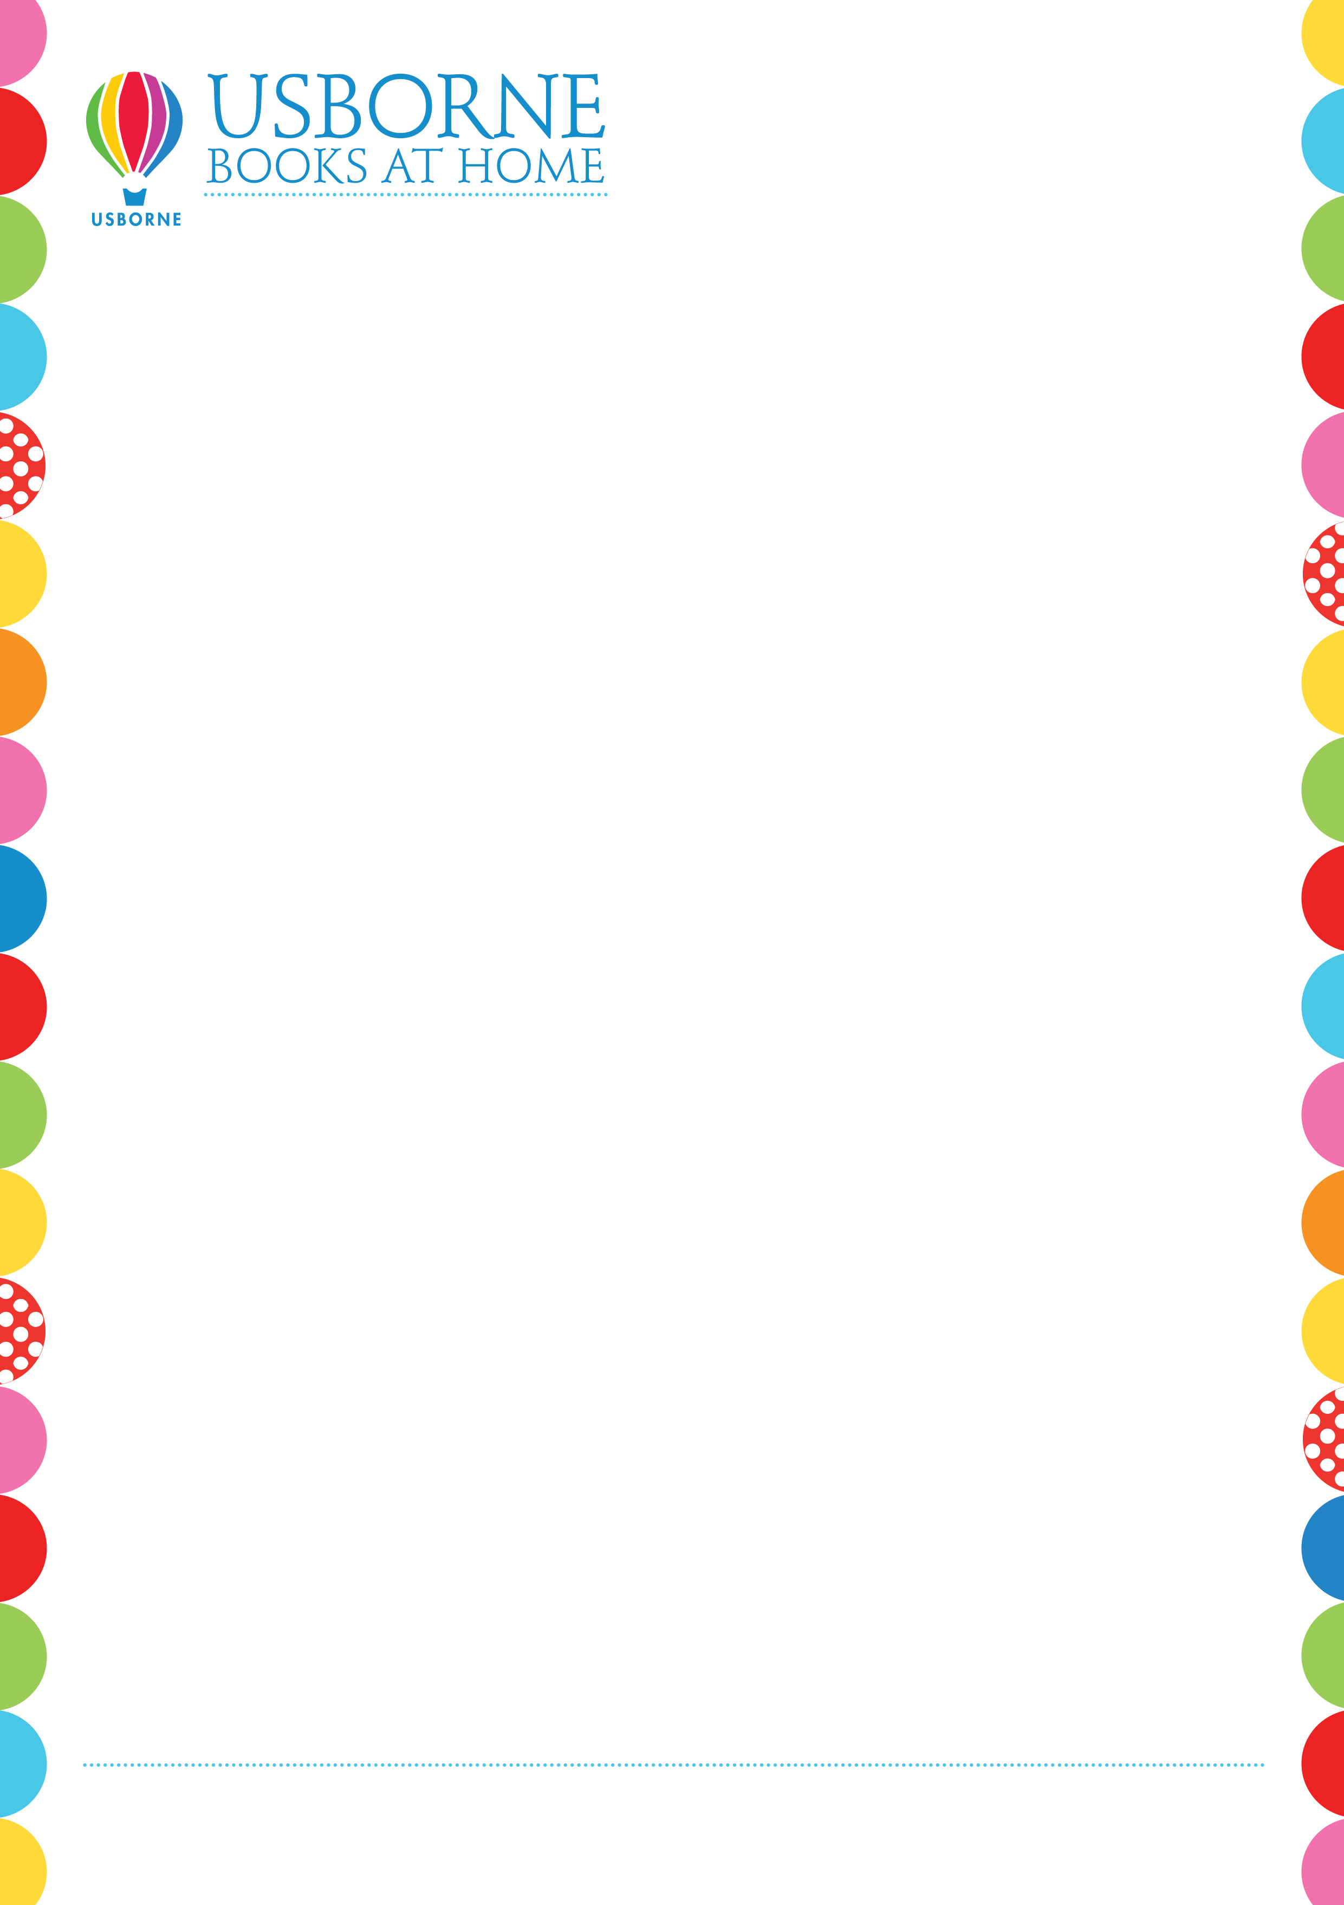
Every book you buy today will help
Gayton Primary get free Usborne books for their classrooms.

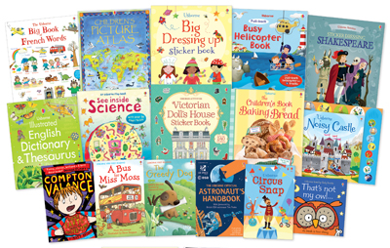

Liz Neale
Independent Usborne Organiser
Mobile: 07793033998
Email: lizslovelybooks@gmail.com
www.lizslovelybooks.co.uk

